Ensuring your trial is designed for all who could benefit

Trial teams need to do everything possible to make their trial relevant to the people to whom the results are intended to apply (often patients) and those expected to apply them (often healthcare professionals). The four questions below are intended to prompt trial teams to think about who should be involved as participants, and how to facilitate their involvement as much as possible. These questions should be considered by trial teams in partnership with patient and public partners, including individuals from, or representing, groups identified in Question 1. Note that:
- ‘Intervention’ means the treatment, initiative or service being evaluated.
- ‘Comparator’ means the what the intervention is being compared to.
- ‘Effective’ means the intervention provides important benefits for people with the disease or condition that is the focus of the trial.
We recommend that trial teams use the worksheets to help them think through their answers to the four key questions.

1. Who should my trial results apply to?
Which groups in the community could benefit from the intervention if it was found effective, or benefit from not having it if it was found ineffective and/or harmful?

2. Are the groups identified in Question 1 likely to respond to the treatment in different ways?
How might the disease or cultural factors mean that some groups in the community respond to, or engage with, the treatment(s) being tested in different ways?

3. Will my trial intervention and/or comparator make it harder for any of the groups identified in Question 1 to engage with the intervention and/or comparator?
How might the intervention and/or comparator, including how they are provided, make it harder for some groups in the community to take part in the trial?

4. Will the way I have planned and designed my trial make it harder for any of the groups identified in Question 1 to consider taking part?
How might elements of trial design, such as eligibility criteria or the recruitment and consent process, make it harder for some groups in the community to take part?
1. Who should my trial results apply to?
[NB. Completed by Shaun Treweek and [ ], University of Aberdeen. We were not involved in this trial, we did not discuss the information on the worksheets with the trial team, and the worksheets were completed retrospectively rather than at trial design, none of which is ideal.
The key documents we used regarding the trial were the final report sent to the funder (NIHR) and the registration document– https://www.journalslibrary.nihr.ac.uk/hta/hta24680/#/abstract and https://www.isrctn.com/ISRCTNISRCTN11111428.
Given the above, the information in the worksheets may not be a proper reflection of the trial because we did not have access to all the trial materials. The information is therefore intended to be illustrative, not definitive.]

The trial is a smoking cessation trial targeting people who have recently stopped smoking with the aim of preventing relapse, i.e. starting smoking again. The trial was run in England and Australia but here we will focus on issues linked to England as we take a UK-focus.
There were four interventions: usual care (which allowed smoking replacement therapy); only smoking replacement (e.g. nicotine patches, electronic cigarettes); structured planning and prompting only with strategies to tackle being tempted to smoke; structured planning and prompting plus smoking replacement. All of these seem like interventions that could potentially offer benefit to all recently quit smokers irrespective of ethnicity.
Data from 2019 show that 13.9% of adults in England smoke. That same government source also has data on smoking by ethnicity, shown below.
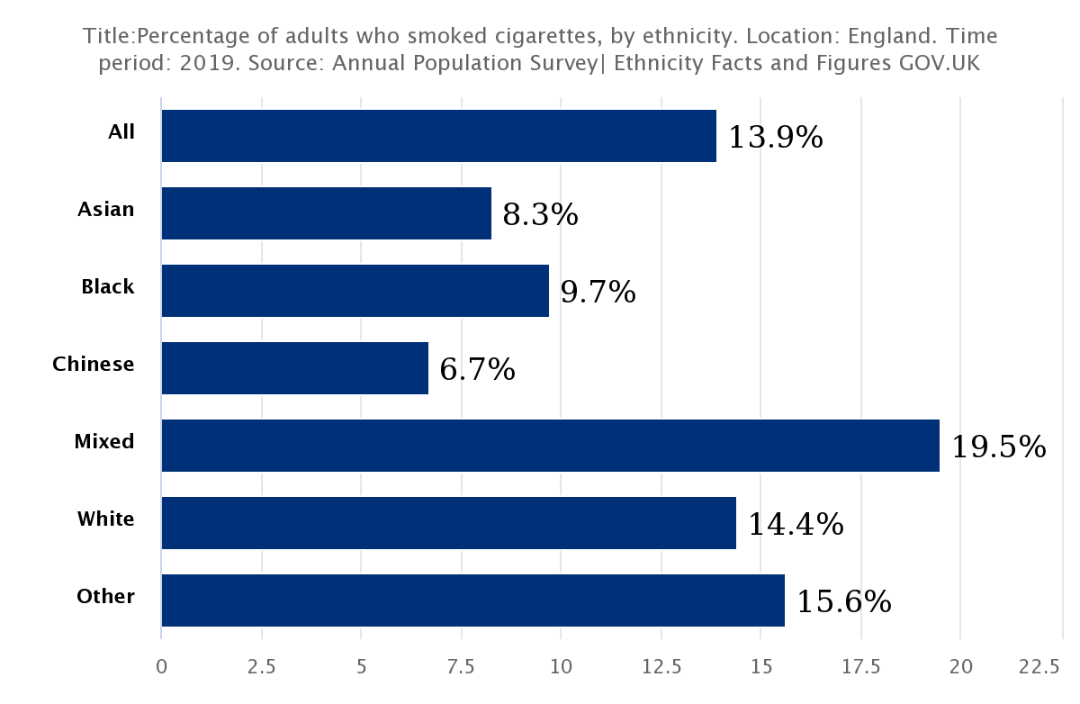
The trial population should aim to look like the UK population of women with breast cancer, bearing in mind that more aggressive cancers are more likely to require surgical and other intervention. Data for England
Data could not be broken down further into the 18 ONS ethnic categories because these smoking data are based on a survey and the survey had too few different ethnicities to allow ethnic groups more specific than the above headline categories. The overall survey was large – 320,000 but (we assume) the number in some ethnic groups who responded was low. The graph shows important differences by ethnic group, with Mixed ethnicity, Other and White being more likely to be smokers than other ethnic groups.
Other data from Action on Smoking and Health (ASH) suggests that for men Mixed and Other ethnic groups smoke most (around 23%) but that men in other ethnic groups all smoke at roughly the same proportion of 15%. Women smoke much less (<10%) although Mixed ethnic groups smoke most at 19%. Asian and Chinese women in particular are much less likely to smoke (3% and 6%, respectively). The ASH data shows that ethnic minority smokers are as motivated to quit as the overall UK population. The White category also includes differences, for example Poles are the largest immigrant group in the UK, have much higher rates of smoking (in Poland) than the general UK population and would (mostly) be categorised as White. The way tobacco is smoked may also vary by ethnic group, with e.g. shisha pipes being used much more by Mixed/Middle eastern groups than White groups.
In summary, the trial should aim for a population of recently quit smokers that reflects the UK population of smokers, which should include a substantial proportion of men and women from Mixed and Other ethnic groups, and Asian, Chinese and Black men, and White men and women.

2. Are the groups identified in Question 1 likely to respond to the treatment in different ways? ( VIEW WORKSHEET )
[This question has been answered with a focus on ethnicity for the purposes of this example, though the questions have wider relevance than ethnicity.]
Data from 2019 show that 13.9% of adults in England smoke. There are important differences by ethnic group, with Mixed ethnicity, Other and White being more likely to be smokers than other ethnic groups. Data from ASH suggest that for men Mixed and Other ethnic groups smoke most (around 23%) but that men in other ethnic groups all smoke at the same proportion of around 15%. Women smoke much less (<10%) although again women from Mixed ethnic groups smoke most at 19%. Asian and Chinese women in particular are much less likely to smoke (3% and 6%, respectively). The ASH data shows that ethnic minority smokers are as motivated to quit as the overall UK population.
In summary, uptake of smoking varies by ethnicity and gender and that Mixed and Other ethnic groups are generally more likely to smoke than White ethnic groups. Trials would need to reflect this.
The consequences of smoking may be greater for some ethnic minority groups. Ethnic minorities living in Britain are at higher risk of a number of smoking related diseases compared to White Britons. Those already more susceptible to these diseases further increase their chances of ill health if they smoke. This includes increased risk of diabetes, stroke and some cancers.
A study that looked at tobacco use among Bangladeshi and Pakistani adults found that smoking among men was seen not only as socially acceptable, but as deeply socially ingrained among Bangladeshi men, contributing to group cohesion and identity. The study concluded that more investment is needed in providing and evaluating culturally sensitive smoking cessation services for South Asian people.
The above source also highlighted the importance of local mapping to understand the profile and prevalence of smoking and tobacco use among minority ethnic groups within local communities.
A systematic review of perceived barriers to smoking cessation that included studies that worked with indigenous communities did find that smoking cessation could exclude an individual from fully participating in their culture or potentially challenge their family, personal or community relationships. While the focus of this work was not the UK, it does suggest that there may be cultural reasons among some ethnic groups (or perhaps some individuals in any ethnic group) that may make smoking cessation more challenging.
More generally, a general distrust in research may reduce the willingness of ethnic minority people to take part in a trial.

3. Will my trial intervention and/or comparator make it harder for any of the groups identified in Question 1 to engage with the intervention and/or comparator? ( VIEW WORKSHEET )
[This question has been answered with a focus on ethnicity for the purposes of this example, though the questions have wider relevance than ethnicity.]
It is not clear if or how any ethnic minority patient partners were involved in the selection of the trial interventions and/or comparator, who delivers the treatments, or where they are delivered. The trial team did however, have PPI as part of their trial, it is just not clear whether ethnic minority individuals were part of this.
There are two interventions, used in combination (or none). One is smoking replacements, the other structured planning and prompting. There is no face-to-face contact, everything is delivered online, on the ‘phone or by text. For smoking replacements, some were provided free initially but after two packs of materials, participants had to start buying their own, which is likely to disadvantage those on low incomes, which affects some ethnic groups more than others (e.g. Chinese and Black people in the UK are more likely to be low income).
Online may be difficult for those of all ethnic groups who don’t have internet access at home, or who are not computer literate. UK Gov data suggest that internet access by 65-74 is 20% lower for Asians (around 65%) than for White British population; data for Black and mixed ethnic background are withheld because of low numbers. Regardless of technical issues, not all ethnic groups may consider online delivery equally acceptable, which means this may be a limit to the participation of some ethnic groups. How acceptable, or useful such interventions might be considered to be by a wide range of ethnic groups is unclear. It would be useful to know to what degree there are differences between ethnic groups in attitudes to self-directed care.
Much of the intervention is provided as written material. There is no discussion of translation/interpretation, or to what extent these are needed by the targeted groups.

- Will the way I have planned and designed my trial make it harder for any of the groups identified in Question 1 to consider taking part? ( VIEW WORKSHEET )
[This question has been answered with a focus on ethnicity for the purposes of this example, though the questions have wider relevance than ethnicity.]
The eligibility criterion that will drive much of the restriction for some ethnic groups is that participants must be in the UK Stop Smoking Services (see Worksheet 2). Other criteria that may be limiting are:
- Participants had to own a mobile phone.
- Participants had to have access to the internet.
- Participants had to be able to read, write and understand English.
The latter is likely to disproportionality affect ethnic minority individuals. It is also unclear how this judgement will be made, although the judgement itself is likely to be made by the referrer/recruiter (initially someone at UK Stop Smoking Services).
No mention is made of translation so an ability to understand written English (for intervention, comparator and consent) seems central. Owning a mobile ‘phone is widespread but will exclude some, either because they don’t own a suitable mobile phone or because they don’t want to use it for healthcare. If participant internet access is only, or primarily, through mobile networks, the cost of data access may be a problem for low-income participants of all ethnic groups (and Black and Chinese people are more likely to be low income.
People at the UK Stop Smoking Service were the first point of contact for potential participants, which limits the participation of ethnic groups in two ways. Firstly, not all ethnic groups attend these services to the same extent (see Worksheet 2). Secondly, recruitment relies on a recruiter informing the potential participant. Any recruitment path that relies on recruiter discretion is open to discrimination, conscious or unconscious.
Eligible patients were given an information sheet by Stop Smoking Service staff and referred to the research team. The research team contacted participants by email, which may introduce the same challenges as the intervention itself re. use of IT for healthcare. It is unclear if the trial team explored who should make the initial approach with an ethnically diverse group of patient and public contributors. Issues of trust in research are likely to be particularly important for Black individuals, and perhaps too those from the Middle East typically categorised as Other by ethnicity UK categorisations, both of which are important groups for this trial based on smoking prevalence.
The primary outcome was relapse rate at 12 months, which seems like a good measure for this trial. Asking about smoking behavior is unlikely to be perceived very differently by ethnic groups, especially since this is a trial about stopping smoking (but needs to be confirmed). There is biochemical testing as part of the trial though for evidence of smoking and that may be perceived differently by different ethnic groups, depending on what individuals think will happen to their biological material and who will have access to the results, and the material itself.
Descriptive background data included age, amount of smoking, employment, quality of life and a range of other items, plus a question about mental health conditions and whether the person was on benefits. Some people of all ethnic groups will find those last two questions concerning and some ethnic groups perhaps more than others. It is unclear to what extent why these data are needed was explained to potential participants.

Worksheets for thinking through factors that might affect ethnic group involvement in a trial

These worksheets are intended to be used by trial teams in partnership with patient and public partners to ensure that ethnic group involvement is considered at the trial design stage. Before completing the worksheets, the trial team should have answered Question 1 of the INCLUDE Key Questions with regard to ethnic group involvement.
The worksheet may cover issues that some trial teams already think about. The intention is that the worksheet will help to highlight issues consistently across trials for all trial teams, as well as raising some questions that may not be routinely considered at present.
Finally, while the worksheet asks trial teams to think about possible differences between ethnic groups, it is important to remember that there are also differences within ethnic groups, especially between generations and between men and women. No ethnic group is homogenous. See Appendix 1 for more on our definition of ethnicity.

Worksheet 1
This worksheet provides some questions to guide your thinking about ethnic group involvement when answering Question 2 of the INCLUDE Key Questions.
Disease and cultural factors that might influence the effect of treatment for some ethnic groups

Disease | How might the prevalence of the disease vary between each ethnic group in the target population? | Response: Data from 2019 show that 13.9% of adults in England smoke. That same government source also provides data on smoking by ethnicity, shown in the figure below. Data could not be broken down further into the 18 ONS ethnic categories because these smoking data are based on a survey and the survey had too few different ethnicities to allow ethnic groups more specific than the broad categories. The overall survey was large – 320,000 but (we assume) the number in some ethnic groups who responded was low. The graph shows important differences by ethnic group, with Mixed ethnicity, Other and White being more likely to be smokers than other ethnic groups.  Data from Action on Smoking and Health (ASH) suggests that for men Mixed and Other ethnic groups smoke most (around 23%) but that men in other ethnic groups all smoke at the same proportion of around 15%. Women smoke much less (<10%) although again women from Mixed ethnic groups smoke most at 19%. Asian and Chinese women in particular are much less likely to smoke (3% and 6%, respectively). The ASH data shows that ethnic minority smokers are as motivated to quit as the overall UK population. The White category also includes differences, for example Poles are the largest immigrant group in the UK, have much higher rates of smoking (in Poland) than the general UK population and would (mostly) be categorised as White.  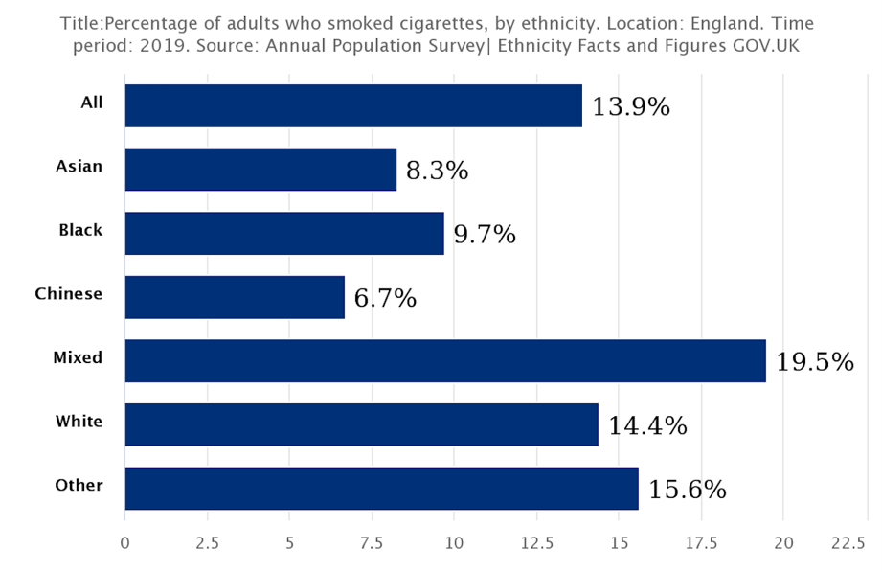  In summary, uptake of smoking varies by ethnicity and gender and that Mixed and Other ethnic groups are generally more likely to smoke than White ethnic groups. Trials would need to reflect this.
 | How might the severity of the disease vary between each ethnic group? | Response: The consequences of smoking may be greater for some ethnic minority groups. Ethnic minorities living in Britain are at higher risk of a number of smoking related diseases compared to White Britons. Those already more susceptible to these diseases further increase their chances of ill health if they smoke. This includes increased risk of diabetes, stroke and some cancers.  The ASH data source given above states that diabetes is more than five times as common among Pakistani women, at least three times as common in Bangladeshi and Black Caribbean women, and two-and-a-half times as common in Indian women, compared with women in the general population. Black people are almost twice as likely to have a stroke than white people; on average, people of black African, black Caribbean and South Asian descent in the UK have strokes earlier on in their lives. Some cancers, e.g. cancer of the mouth in Asian women over 65), are more common in ethnic minorities than White individuals.  The benefits of stopping smoking may therefore be greater for some ethnic minority groups than for White individuals. A trial needs to ensure that smokers at greatest risk (and therefore who are likely to benefit most from stopping) are reflected in the trial population. Pakistani, Bangladeshi, other South Asians and Black people are important groups for the trial.
 | How might the disease present in people from each ethnic group (this may include symptoms, type or pattern or rate of disease progression)? | Response: Smoking tobacco is the main form of smoking for all smokers in the UK, including those from ethnic minority groups.  However, the way tobacco is smoked may also vary by ethnic group, with e.g. shisha pipes being used much more by Mixed/Middle eastern groups than White groups. Some ethnic minorities are substantially more likely to use smokeless tobacco, in particular, South Asian Britons.  However, smoking remains the most common form of tobacco use in all communities.
 | How close is the match between each ethnic group living with the disease and the ethnic groups living in the areas where the trial is to be run? | Response: The original trial plan was to recruit (in England) at Tower Hamlets, City of London, Leicester, Medway, Birkenhead and Durham. This was later extended to those trying to quit through Stoptober 2018.  London (and Tower Hamlets in particular) is ethnically diverse, as is Leicester. A potential challenge though is that potential participants have to come through UK Stop Smoking Services in these areas, rather than being recruited directly from the community. This means that the match between trial and ethnic groups trying to quit smoking depends on who uses the Stop Smoking Services, which may not be the same as the smoking population as a whole in a particular area.  Data on the ethnicity of those attending Stop Smoking Services show that ethnic minority individuals represent around 10% of users who stated their ethnicity. This does put a ceiling (without active oversampling) on the proportion of trial participants who could come from ethnic minorities. Other data on these services from the Race Equality Foundation suggest that fewer than 6% of services users are from ethnic minority groups. It is unclear if people using these Stop Smoking services are different in other than ways that with regard to ethnicity from those who want to quit but do not use the service.  In other words, while the geographic areas selected ought to provide a diverse mix of ethnicities, the referral route through Stop Smoking Services may well reduce this diversity.
 | Other factors to consider:
Cultural | How might perceptions of the disease and social stigma around it be different for each ethnic group in the target population? | Response: A study that looked at tobacco use among Bangladeshi and Pakistani adults found that smoking among men was seen not only as socially acceptable, but as deeply socially ingrained among Bangladeshi men, contributing to group cohesion and identity. The study concluded that more investment is needed in providing and evaluating culturally sensitive smoking cessation services for South Asian people.  The above source also highlighted the importance of local mapping to understand the profile and prevalence of smoking and tobacco use among minority ethnic groups within local communities.  A systematic review of perceived barriers to smoking cessation that included studies that worked with indigenous communities did find that smoking cessation could exclude an individual from fully participating in their culture or potentially challenge their family, personal or community relationships. While the focus of this work was not the UK, it does suggest that there may be cultural reasons among some ethnic groups (or perhaps some individuals in any ethnic group) that may make smoking cessation more challenging.
 | How might ways of describing the disease be different for each ethnic group? | Response: It is likely that stopping smoking is easily understood by all ethnic groups. The consequences of smoking (and hence the importance of stopping) may vary by ethnic group (see above).
 | How might cultural practices, beliefs and traditions influence the acceptability of, and adherence to, the treatment(s) for each ethnic group? | Response: The interventions are smoking replacements (e.g. nicotine patches) and/or structured planning and prompts. How acceptable, or useful such interventions might be considered to be by a wide range of ethnic groups is unclear. It is also unclear to what degree self-management/self-directed care is a concept that works equally across different ethnic groups. There is evidence from other conditions such as cardiovascular disease and diabetes that cultural values need to be integrated with self-management plans for them to be effective and self-led work to stop smoking may be viewed similarly.  More generally, many South Asian people are unwilling to participate in trials because they accept their illness as an unalterable punishment from God, or have a fear of what research entails. A mistrust of research is common among many ethnic minority individuals, especially Black people, in large part because of examples of unethical/racist research practice in the past.
 | How or when might people in each ethnic group access healthcare for this disease differently? | Response: The key issue is whether all ethnic groups use UK Stop Smoking Services equally, which seems unlikely (see above).  Additionally, research has shown that health promotion activities such as smoking cessation tend to be based on assumptions of individualism and self-investment, which may need to be re-thought for South Asian groups in particular where community is often more important.  South Asians are often explicitly excluded from research due to perceived cultural and communication difficulties. Language and cultural differences are barriers that impact all minority groups – with people from non-White-European populations seeking healthcare at later stages of their disease than their White counterparts. Language and literacy factors are also known factors that impact on overall health literacy. Study participants have reported that both the spoken and written health information provided were sometimes meaningless, even when translated into their own language. Their inability to transform information into action was either due to limited health knowledge or limited linguistic proficiency in either their native language or English and they also felt they were unable to maximise their consultation with their healthcare professional.
 | Other factors to consider:
Worksheet 2
This this worksheet provides some questions to guide your thinking about ethnic group involvement when answering Question 3 of the INCLUDE Key Questions.

Intervention and comparator factors that might affect how some groups engage with the intervention and/or comparator*

What | How might the intervention(s) and comparator limit participation of people from each ethnic group in the target population? | Response: There are two interventions, used in combination (or none). One is smoking replacements, the other structured planning and prompting. There is no face-to-face contact, everything is delivered online, on the ‘phone or by text. For smoking replacements, some were provided free initially but after two packs of materials, participants had to start buying their own, which is likely to disadvantage those on low incomes, which affects some ethnic groups more than others (e.g. Chinese and Black people in the UK are more likely to be low income).  To what extent written materials had been developed together with members of different ethnic groups is unclear. No mention of translation is mentioned, which could be a problem, particularly for older South Asian women. Moreover, materials would need cultural tailoring, which seems unlikely to have been the case.  Material targeting the individual is a strategy that works from a White ethnic group perspective but may be less effective in South Asians (who tend to have more of a sense of community, so appeals to community may be useful) and Black individuals, where appeals to family may be more useful.  How acceptable, or useful such interventions might be considered to be by a wide range of ethnic groups is unclear. It would be useful to know to what degree there are differences between ethnic groups in attitudes to self-directed care.
 | How, and in what way, were people from each ethnic group involved in selecting or designing the trial intervention/comparator? | Response: There was patient and public involvement but there is no information regarding the ethnicity of these individuals. Without special efforts, it is reasonable to assume that the PPI will have been from a predominantly White perspective, as it is for most UK trials.
 | Other factors to consider:
Who | How might the person delivering the intervention/comparator limit participation of people from each ethnic group in the target population? | Response: The intervention is delivered remotely, there is no face-to-face delivery. That does remove the potential for some problems, but potentially introduces others (e.g. familiarity with/willingness to use online resources for healthcare).  See other sections in Worksheet 2.
 | Other factors to consider:
How | How might the mode of delivery (e.g. telephone, video-call, face-to-face, in groups) limit participation of people from each of the ethnic groups in the target population? | Response: The mode of delivery of the interventions/comparator is remote: online, telephone or by text.  Online may be difficult for those of all ethnic groups who don’t have internet access at home, or who are not computer literate. UK Gov data suggest that internet access by 65-74 is 20% lower for Asians (around 65%) than for White British population; data for Black and mixed ethnic background are withheld because of low numbers. Regardless of technical issues, not all ethnic groups may consider online delivery equally acceptable, which means this may be a limit to the participation of some ethnic groups.  There is no mention of translation despite the heavy use of written material and the high degree of smoking among, especially Mixed and Other ethnic groups. It is unclear if translation is essential but explicit consideration is needed. Text-message based delivery requires a participant to consider a mobile ‘phone to be a sensible healthcare tool. This is more than whether people have a mobile (most will, though not all), it is whether different ethnic groups consider a mobile ‘phone to be equally useful or valid as a healthcare tool.  In summary, it is unclear how acceptable the mode of delivery is to different ethnic groups, or how this might therefore limit the participation of some groups. As stated in a report from Public Health Wales on inequalities, interventions need to be culturally tailored, and this includes mode of delivery.
 | Other factors to consider:
Where | How might where the intervention/comparator is delivered (e.g. hospital, general practice, local library) limit the participation of people from each ethnic group in the target population? | Response: As above.
 | Other factors to consider:
When & Intensity | How might when the intervention/comparator is delivered (e.g. during working hours) or the intensity (e.g. number of times it is delivered, over what period, time commitment for each session and overall) limit participation of people from each ethnic group in the target population? | Response: The intervention/comparator delivery is all done remotely which allows a participant flexibility as to when to access it. Total follow-up time was 12 months although this was curtailed because the trial was stopped early because of poor recruitment. The number of messages seems high (72 or 55 depending on arm) although it is spread over a long period so probably not too intrusive. There were other streams of messages too, with 12-17 messages each. Not all participants received these messages though, depending on allocation. Those on smoking replacement just received the replacements although only two batches.  There was telephone help at the start (eligibility screening and 1 week after randomization). It is not clear if this was available beyond 1 week, with everything then being online.  It is unclear to what extent this workload is acceptable to different (or any) ethnic groups.
 | Other factors to consider:

*These factors are taken from TIDieR (http://www.equator-network.org/reporting-guidelines/tidier/).

Worksheet 3a
This worksheet provides some questions to guide your thinking about ethnic group involvement when answering Question 4 of the INCLUDE Key Questions.

Trial eligibility and participation factors that might affect how some groups engage with the trial
Eligibility | How might eligibility criteria exclude members of each ethnic group in the target population for reasons other than their clinical eligibility for the trial (e.g. availability of medical history, must speak English, location, gender, age, discussing pregnancy, internet/mobile telephone access)? | Response: The eligibility criterion that will drive much of the restriction for some ethnic groups is that participants must be in the UK Stop Smoking Services (see Worksheet 2). Other criteria that may be limiting are:  - Participants had to own a mobile phone.  - Participants had to have access to the internet.  - Participants had to be able to read, write and understand English.  The latter is likely to disproportionality affect ethnic minority individuals. It is also unclear how this judgement will be made, although the judgement itself is likely to be made by the referrer/recruiter (initially someone at UK Stop Smoking Services).  No mention is made of translation so an ability to understand written English (for intervention, comparator and consent) seems central. Owning a mobile ‘phone is widespread but will exclude some, either because they don’t own a suitable mobile phone or because they don’t want to use it for healthcare. If participant internet access is only, or primarily, through mobile networks, the cost of data access may be a problem for low-income participants of all ethnic groups (and Black and Chinese people are more likely to be low income.
 | Other factors to consider:
Opportunity to participate | How might the way(s) (and by whom) potential participants are made aware of the trial (e.g. posters in clinic, written letter from a doctor, asked by a nurse) limit the participation of each ethnic group in the target population? | Response: People at the UK Stop Smoking Service were the first point of contact for potential participants, which limits the participation of ethnic groups in two ways. Firstly, not all ethnic groups attend these services to the same extent (see Worksheet 2). Secondly, recruitment relies on a recruiter informing the potential participant. Any recruitment path that relies on recruiter discretion is open to discrimination, conscious or unconscious.  Eligible patients were given an information sheet by Stop Smoking Service staff and referred to the research team. The research team contacted participants by email, which may introduce the same challenges as the intervention itself re. use of IT for healthcare.  The eligibility criteria mentioned above may lead to some ethnic groups being disproportionately affected as they criteria are subjective and judgement-based. Depending on the language skills of both potential participants and staff, who approaches the potential participant may limit the ability of some ethnic groups (older Pakistani and Bangladeshi women, recent immigrants for example) to participate.  It is unclear if the trial team explored who should make the initial approach with an ethnically diverse group of patient and public contributors. Issues of trust in research are likely to be particularly important for Black individuals, and perhaps too those from the Middle East typically categorised as Other by ethnicity UK categorisations, both of which are important groups for this trial based on smoking prevalence.
 | How might the information that tells potential participants about the trial (e.g. participant information leaflet) limit the participation of each ethnic group? | Response: As some ethnic groups including individuals for whom English may not be their first language are a key required group within the trial (e.g. South Asians, Indian subcontinent, Other) then translation of written and oral material into some languages other than English is likely to be important.  It is unclear if the written/verbal information has been developed together with people from a range of ethnic groups.
 | How might cultural practices, beliefs and traditions change the way each ethnic group perceives the information they are given? | Response: See earlier comments about self-management and appeals to individualism rather than community and family (Worksheet 2).
 | Other factors to consider:
Consent procedures | How might the way consent is sought (i.e. where, by whom, written vs verbal, verbal translations/multiple languages, access to interpreters) limit the participation of each ethnic group in the target population? | Response: Consent is written or verbal, which is inclusive.  The language-based eligibility criterion highlighted above will disproportionality affect ethnic minority groups.
 | How might the way people would like to discuss participation with family before providing consent differ for each ethnic group? | Response: South Asian women, particularly older women, are known to make decisions about their healthcare in consultation with members of their community and family. Community views are generally important for South Asian people of all genders. Awareness of community views on smoking cessations, plus Involvement of family members in the consent process should therefore be considered. Family is also important to people with Black heritage. Potential participants are given time to consider their involvement so this should be possible in all or many cases in principle.
 | How might the way the research team can check how well consent information is understood differ for each ethnic group? | Response: There is no information about how understanding is confirmed.
 | Other factors to consider:

Worksheet 3b
This worksheet provides some questions to guide your thinking about ethnic group involvement when answering Question 4 of the INCLUDE Key Questions.
Trial data collection factors that might affect how some groups engage with the trial

What | How, and in what way, were people from each ethnic group in the target population involved in selecting the trial outcomes? | Response: Public contributors have been involved but it is not clear if they were involved in outcome choice, or whether there was ethnically diverse membership of PPI groups. Without special efforts, it is likely that UK PPI is dominated by White British perspectives.
 | How might the trial outcomes themselves, or other data being collected (e.g. a patient’s background information) limit the participation of each ethnic group? | Response: The primary outcome was relapse rate at 12 months, which seems like a good measure for this trial. Asking about smoking behavior is unlikely to be perceived very differently by ethnic groups, especially since this is a trial about stopping smoking (but needs to be confirmed). There is biochemical testing as part of the trial though for evidence of smoking and that may be perceived differently by different ethnic groups, depending on what individuals think will happen to their biological material and who will have access to the results, and the material itself.  Descriptive background data included age, amount of smoking, employment, quality of life and a range of other items, plus a question about mental health conditions and whether the person was on benefits. Some people of all ethnic groups will find those last two questions concerning and some ethnic groups perhaps more than others. It is unclear to what extent why these data are needed was explained to potential participants.
 | Other factors to consider:
Who | How might the people who collect data limit the participation of each ethnic group in the target population? | Response: Data are all collected online or on the ‘phone. This in itself might limit the participation of some ethnic groups because of literacy and language issues.
 | Other factors to consider:
How | How might data collection methods limit the participation of each ethnic group in the target population? | Response: See above.
 | Other factors to consider:
Where | How might where data are collected limit the participation of each ethnic group in the target population? | Response: See above.
 | Other factors to consider:

Worksheet 3c
This worksheet provides some questions to guide your thinking about ethnic group involvement when answering Question 4 of the INCLUDE Key Questions.
Factors that might affect the planned analysis of trial results

Retention | How might the trial data available for participants differ between each ethnic group in the target population? | Response: See Worksheet 3b.
 | Other factors to consider:
Benefits | How might the benefits of the trial intervention(s) differ between each ethnic group in the target population? | Response: It is conceivable that there may be a cultural element to how acceptable remote, online/mobile phone-based interventions for health are although this is uncertain. Having to buy your own smoking replacements after two packs had been provided by the trial may lead to differential effects by income, which could be felt more by some ethnic groups than others (e.g. Black, Chinese, Bangladeshi).
 | Other factors to consider:
Harms | How might the possible harms of the trial intervention(s) differ between each ethnic group in the target population? | Response: As above.
 | Other factors to consider:
Subgroup analyses | How should variation between ethnic groups in the target population be explored– should there be planned subgroup analyses? | Response: An exploration of benefits and harms by ethnic group should be pre-planned.  The need for this pre-planned subgroup analysis suggests that over-sampling by ethnicity might be useful. This is unlikely to affect the applicability of the evidence to the majority population but will improve the certainty of conclusions coming from the subgroup analysis. The overall sample size does not need to be changed and it is unlikely to be feasible to fully power any subgroup analyses.  Good descriptions of study population would help with later meta-analysis where data for ethnic groups could be combined.
 | Other factors to consider:
Interim analyses | How should any interim analysis handle variation between ethnic groups in the target population? | Response: Any planned interim analysis should look for signals suggesting that benefits or harms were importantly different in one or more ethnic groups. The certainty available for this will be less than for the majority population, although oversampling may help.
 | Other factors to consider:
Stopping triggers | How should any rules to stop the trial early on safety or benefit grounds handle variation between ethnic groups in the target population? | Response: Any stopping rules should consider the benefits or harms by ethnic group. The certainty available for this will be less than for the majority population, although oversampling may help.
 | Other factors to consider:

Worksheet 3d
This this worksheet provides some questions to guide your thinking about ethnic group involvement when answering Question 4 of the INCLUDE Key Questions.
Factors that might affect the planned reporting and dissemination of trial results

What | How, and in what way, were people from each ethnic group in the target population involved in planning the reporting and dissemination of the trial results? | Response: Public contributors were part of the trial but it is not clear if or how they were involved in planning the reporting and dissemination of the trial results. There is no suggestion that the PPI was ethnically diverse.
 | Other factors to consider:
How | How might planned reporting and dissemination methods limit engagement with each ethnic group in the target population? | Response: It is uncertain what dissemination plans are in place beyond publications.  Using publications as the only form of dissemination is not conducive to engaging any ethnic group, or member of the public with the results of this trial. The full NIHR publication is open access though.
 | Other factors to consider:
Where | How might where trial results are planned to be reported and disseminated limit engagement of each ethnic group in the target population? | Response: The NIHR journal library provides the bulk of what is likely to be publicly available on this trial.  Using publications as the only form of dissemination is not conducive to engaging any ethnic group, or member of the public with the results of this trial. At the very least the publication(s) that come from this trial should be open access.  Dissemination materials intended for the public should consider the health beliefs, health literacy and languages of the ethnic groups in the community and use channels appropriate for the ethnic group. For example, community radio can be a useful tool for some ethnic groups (e.g. Sikhs), as can social media.
 | Other factors to consider:

Worksheet for thinking through measures to address factors that might prevent full community involvement
Use this worksheet to list key factors that might affect the involvement of some ethnic groups in the target population of your trial, along with measures to mitigate the effect of those factors and their cost. Add extra rows as needed.
Please remember that there are also differences within ethnic groups, especially between generations and between men and women. No ethnic group is homogenous.

Factors that may prevent full community involvement | Proposed measures (several options may be needed)* | Cost of measures
*See https://centreforbmehealth.org.uk/resources/toolkits/ for suggestions for how to address factors that affect community-wide involvement.

Acknowledgements
In addition to Trial Forge and NIHR, this work has involved and been supported by the following:

Centre for Ethnic Health Research

Health Research Board Trial Methodology Research
Network

NIHR-Medical Research Council Trial Methodology
Research Partnership

UK Research and Innovation & Medical Research
Council

